|  |  |  |
| --- | --- | --- |
| **Project명** | Roadwiki | |
| **단계** | Sub3 | |
| **진행일자** | 2021.02.04 | |
| **예상 개발 기간** | 필수기능 | 2021.02.11 |
| 추가기능 | 2021.02.15 |
| 심화기능 | 2021.02.17 |

1. **UI 개선 – 로드맵 디자인 수정**

**(frontend/src/views/RoadMap/ RoadMap.vue)**

* [fix] Roadmap 페이지 UI 개선

Before

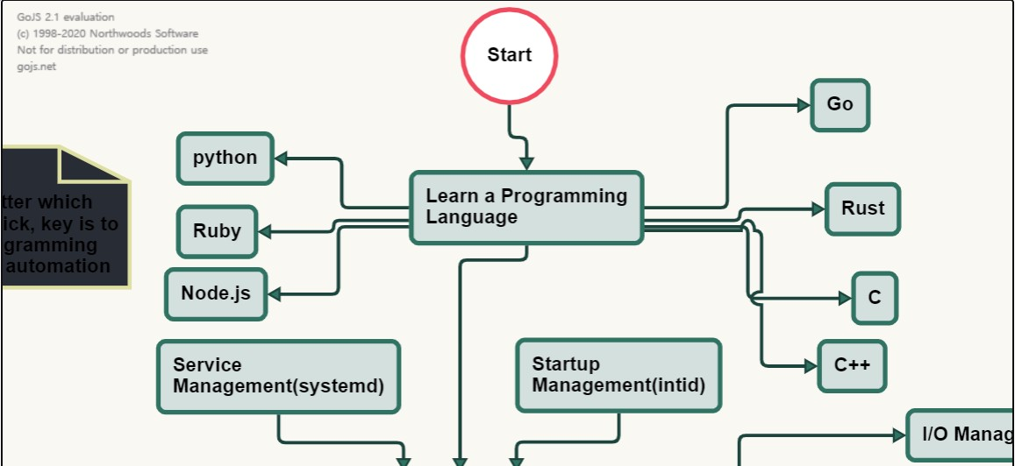

After

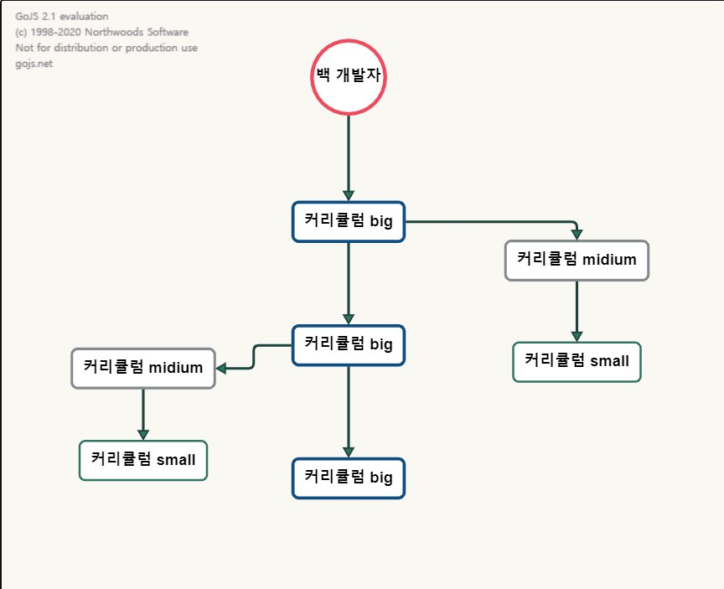

Before

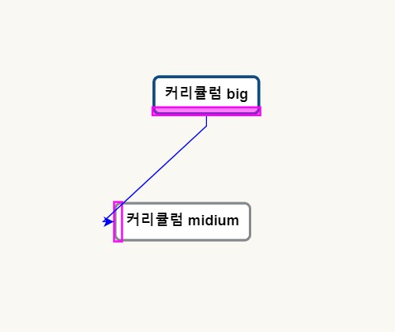

After

